- Issue Date should not be greater than current date. 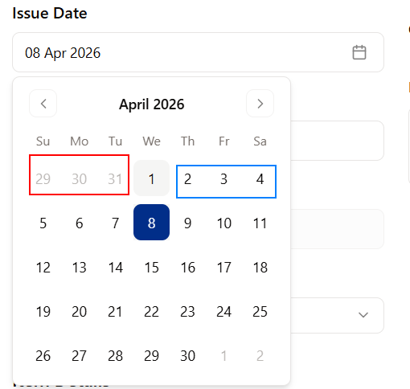
As current gate pass system you can only select backward date.
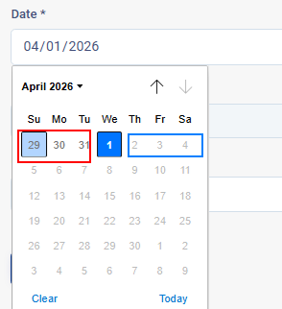
- Format of date and alignment of date picker should be same.

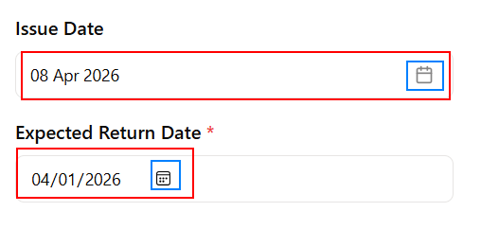

- As per the error phone number format in Add Customer is same as mentioned but it’s still giving an error. But…when I am changing number it’s accepting, like I just change last number 5 with 6 and it’s adding this customer.
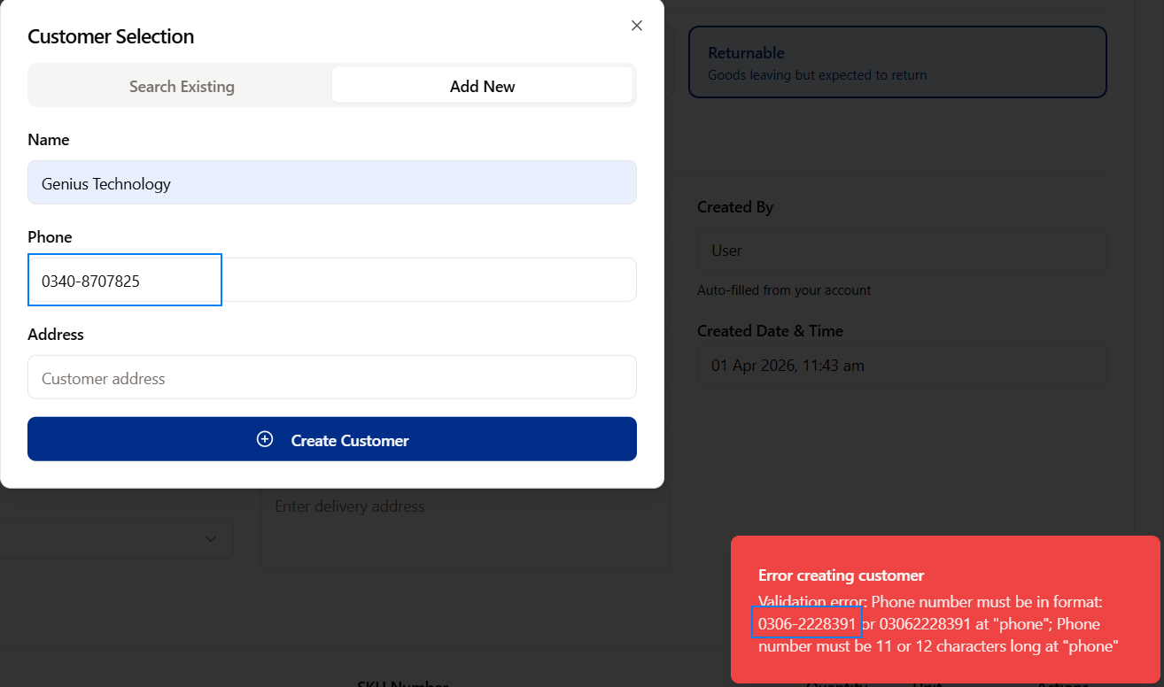
- Departments should be like Information Solutions, Supply Chain etc.. It will not be HO.
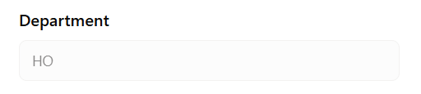
- One option should be added i.e., Company Name: AGP and OBSAGP. Because there are two companies who are accessing and creating gate passes.
- Gate 4 should be the only option to out any item or assets.
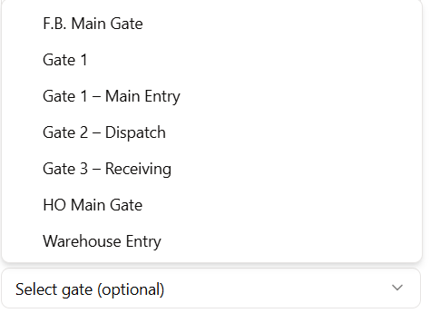

- Items quantity by default showing “1” its confusing for Layman.
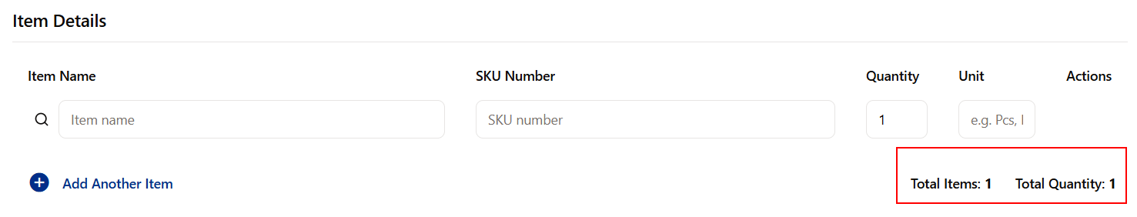
- As per the above pic, Type filed should be added like “Asset” , “Material” and “Other”. Then Item Name quantity etc. Like Below Pic.
- Some fields should not be required, they should be optional or In-person Input field.
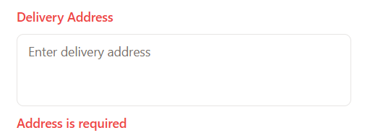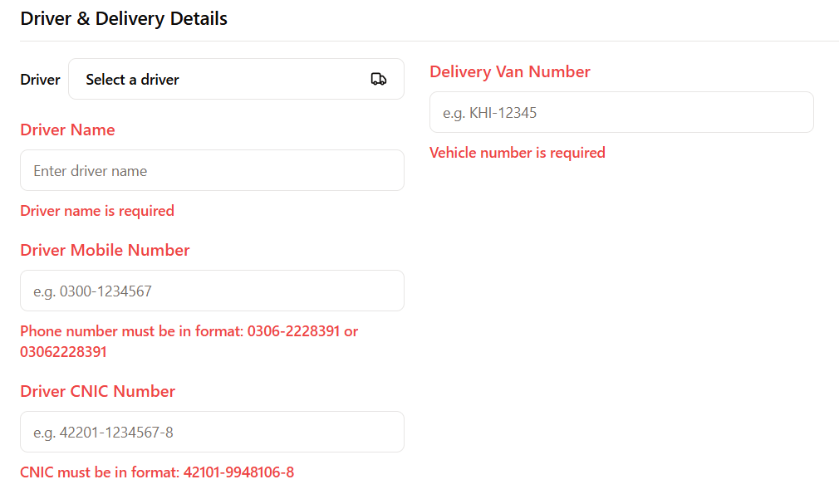
- On HOD Approver Screen, When I am trying filtering recent gate pass its not showing. Otherwise its showing on dashboard.
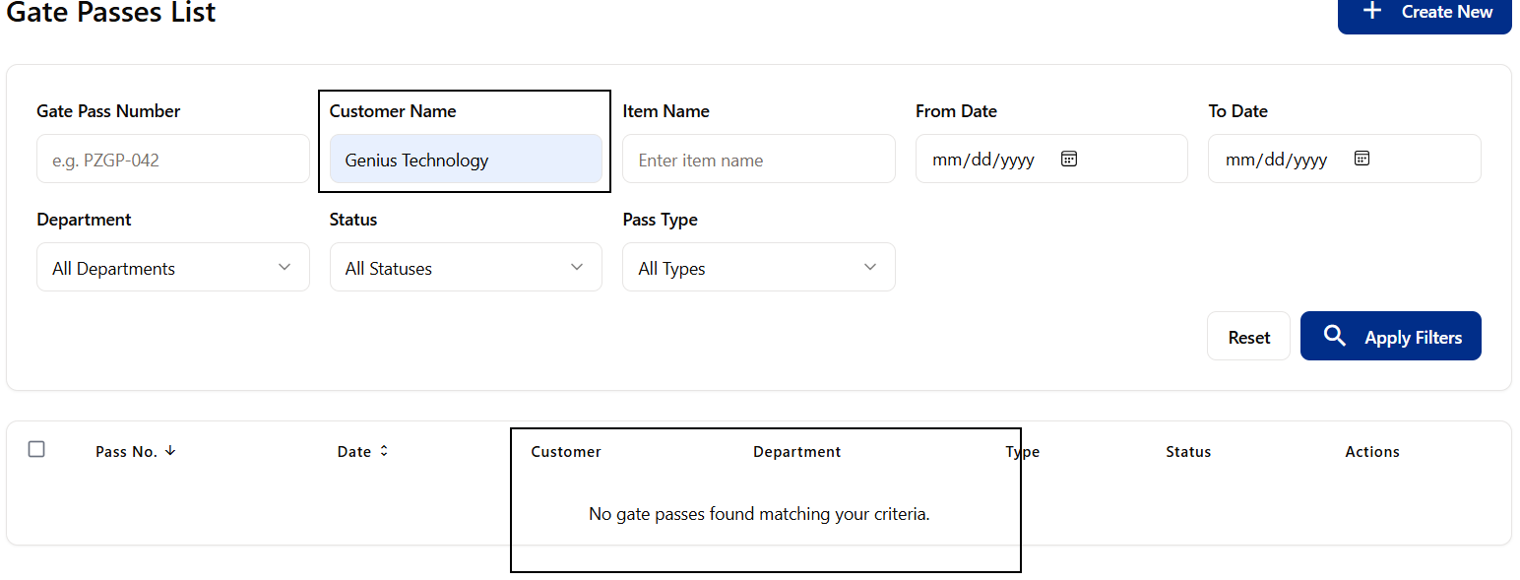

- No 2nd Approval required. Only 1 of the approval from approver is enough.
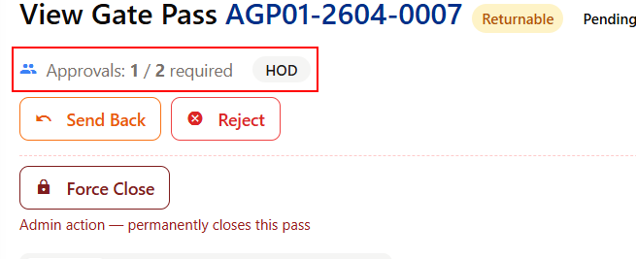
- After 1st approval 2nd approval is not showing on HOD ID, or maybe it’s going elsewhere.
- The overall design is not user-friendly and requires modification or simplification. Furthermore, the fields are not properly aligned.

